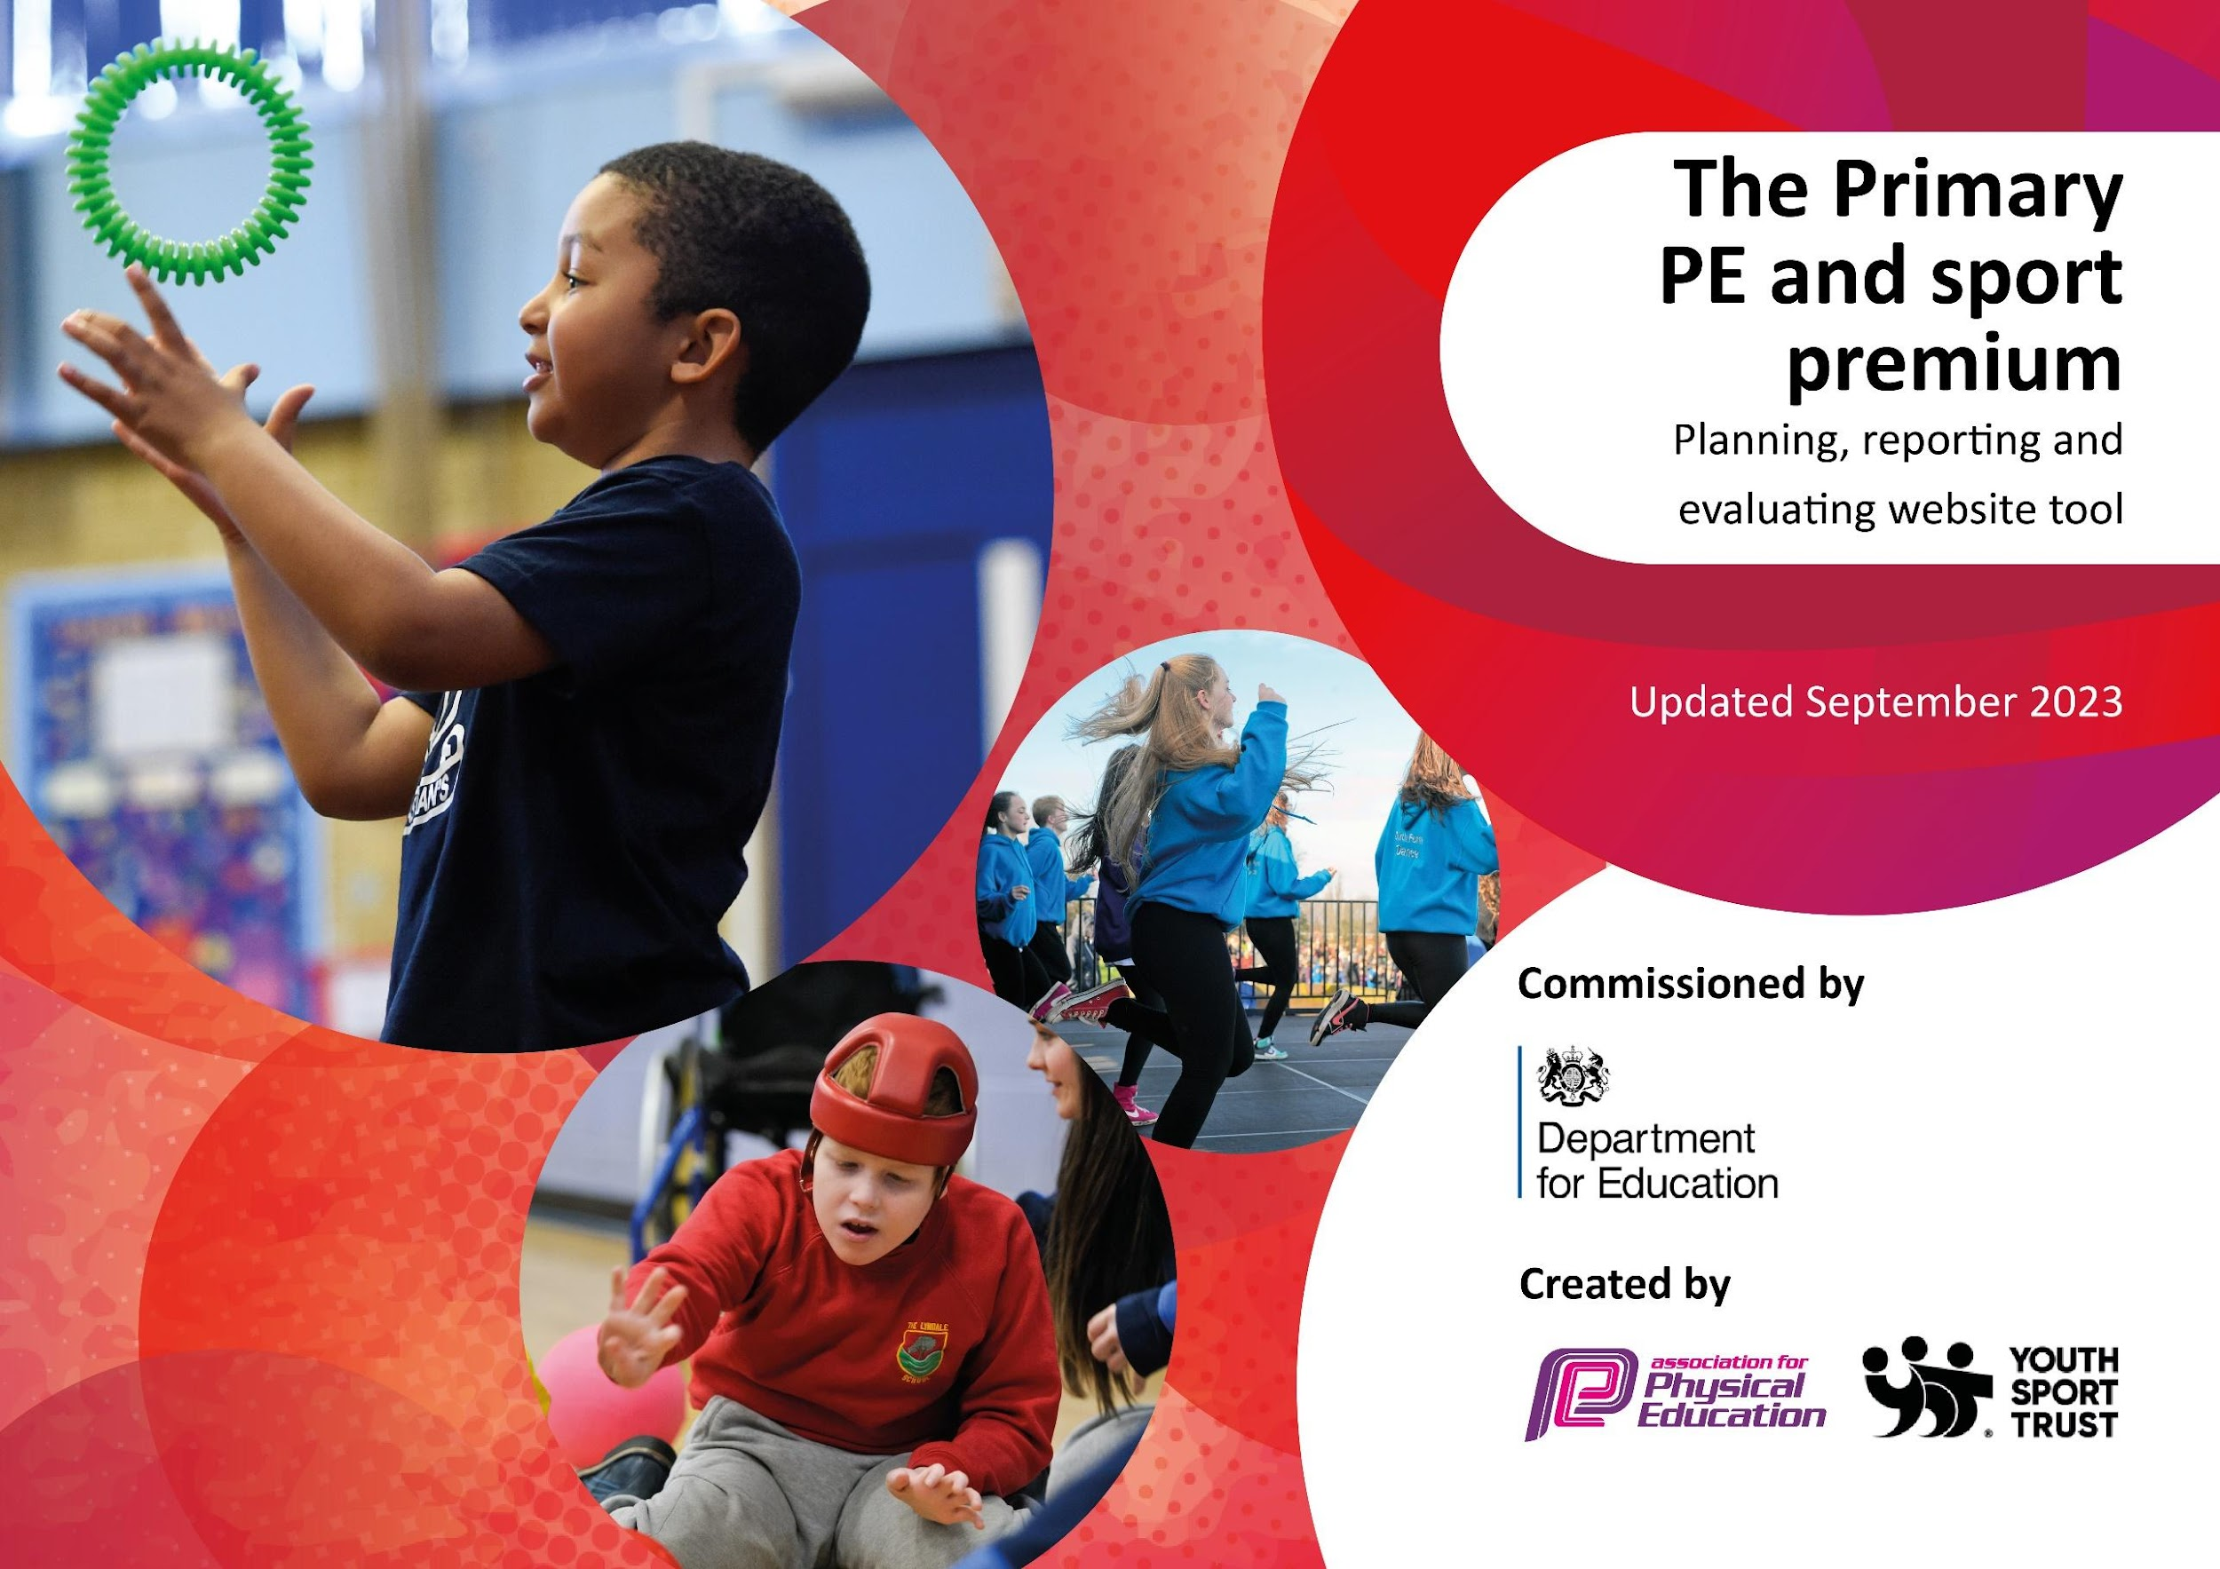

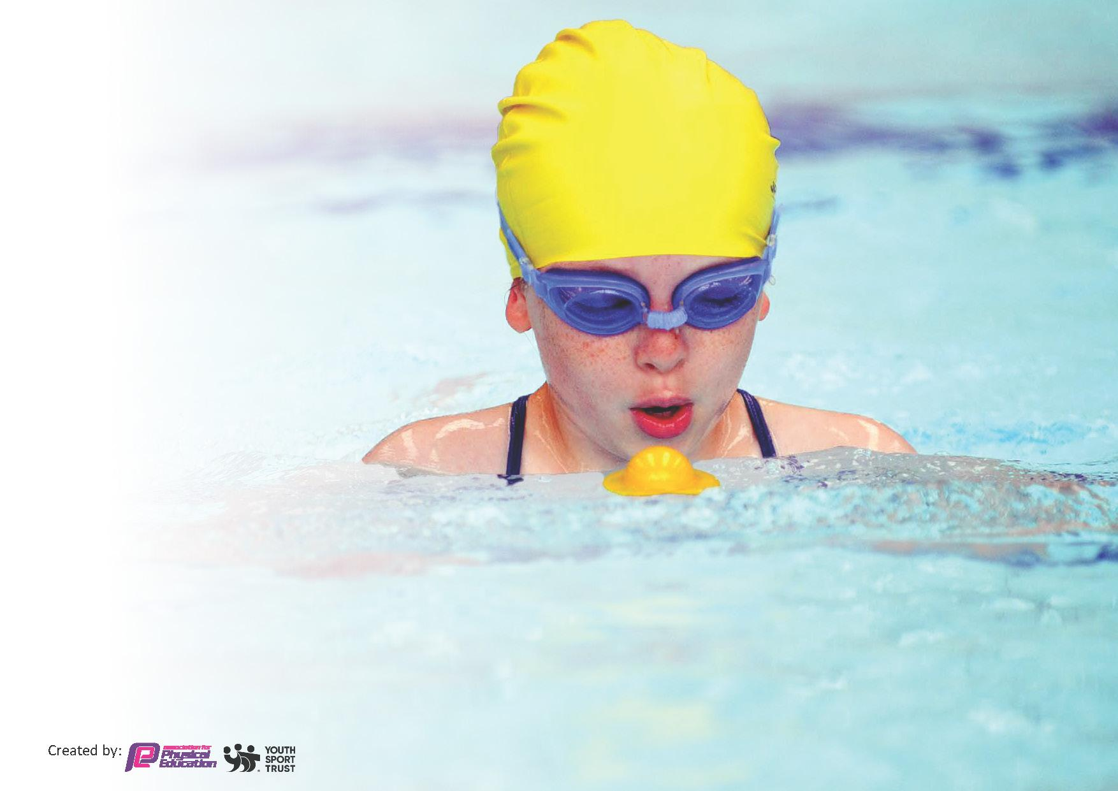
This template can be used for multiple purposes:
by:
- It enables schools to effectively plan their use of the Primary PE and sport premium
- It helps schools to meet the requirements (as set out in guidance) to publish information on their Primary PE and sport premium
- It will be an effective document to support Ofsted inspections enabling schools to evidence progress in Physical Education (PE) and evidence swimming attainment, which forms part of the PE National Curriculum. We would recommend schools consider
the Intent, Implementation and Impact of any spend, as examined within the Education Inspection Framework.

It is important that your grant is used effectively and based on school need.

Schools must use the funding to make additional and sustainable
improvements to the quality of the PE, School Sport and Physical Activity (PESSPA)
they offer. This means that you should use the Primary PE and sport premium to:

- Build capacity and capability within the school to ensure that improvements made now will benefit pupils joining the school in future years
- Develop or add to the PESSPA activities that your school already offers.

The Primary PE and sport premium should not be used to fund capital spend projects; the school’s core budget should fund these. Further detail on capital expenditure can be found in the updated Primary PE and sport premium guidance.

The Primary PE and sport premium guidance, outlines 5 key priorities that funding should be used towards. It is not necessary that spending has to meet all the key priorities, you should select the priorities that you aim to use any funding towards.

Although completing this template is not a requirement for schools, schools are required to publish details of how they spend this funding. Schools must also outline what the impact this funding has had on pupils’ PE and sport participation and attainment and how any spending will be sustainable in the future. All funding must be spent by 31st July 2024.

The Department for Education has worked closely with the Association for Physical Education (afPE) and the Youth Sport Trust (YST) to develop this template and encourages schools to use it. This template is an effective way of meeting the reporting requirements of the Primary PE and sport premium.

Review of last year’s spend and key achievements (2022/2023)

We recommend you start by reflecting on the impact of current provision and reviewing your previous spend.

Activity/Action | Impact | Comments
PE Leader qualified at level 1 and the level 2 Swimming Teacher | Students have received high quality swimming lessons adapted by a SEND specialist now qualified to teach swimming.  Class teachers and Teaching Assistants taught techniques to support students learning to swim in sessions they attend. | The qualification was mainly focused at a level beyond the students, however it has developed practice and the progression planning in swimming is much improved from the course.
New activities developed and resourced using hoops and targets. | Lower ability students more engaged in PE lessons. | Development of new activities in the primary curriculum offer.
Development of the curriculum progression | Students engaged in a range of activities and are developing physical skills. | Clear progression to develop the skills to engage in competitive sports.
Additional swimming sessions, throughout the year. | Students continue to gain confidence in water and are developing the skills to stay safe.  Supports meeting the Chief’s Medical Officer’s target for physical activity. | The majority of students are happy in the pool and it often encourages student’s communications.  Swimming also gets some of the students who engage the least in physical activity moving and active.

Key priorities and Planning
This planning template will allow schools to accurately plan their spending.

Action – what are you planning to do | Who does this action impact? | Key indicator to meet | Impacts and how sustainability will be achieved? | Cost linked to the action  Total allocation: £16,710  Total spend: £18,080.98+

African dance day | All pupils | KI3: Raising the profile of PE and sport across the school, to support whole school improvement  KI4: Offer a broader and more equal experience of a range of sports and physical activities to all pupils | Broadened experiences of all primary students engaged in new style of dance.  Whole day event raised profile of PE within school staff and the students. | £498 External dance provider
Trampoline activities | Key Stage 2 students | KI3: Raising the profile of PE and sport across the school, to support whole school improvement  KI4: Offer a broader and more equal experience of a range of sports and physical activities to all pupils | Pupils to try and be engaged in physical activity.  To know different places they can enjoy physical activity | £380 ‘Gravity’  £268 ‘Top Jump’
Develop activities to engage young people in physical activity outside of PE lessons including at unstructured times | Primary YR to Y5  at Hertford Place  Year 6 + at Hazeley | KI1: Increasing all staff’s confidence, knowledge and skills in teaching PE and sport  KI2: Increasing engagement of all pupils in regular physical activity and sport  KI3: Raising the profile of PE and sport across the school, to support whole school improvement | Pupils to be active at playtimes and lunch times now and in the future. Pupils to also have resources in classrooms to encourage physical activity.  Staff have the right resources to deliver activities outside of PE lessons, next steps to make sustainable are to give staff support in using equipment. | £4,200 ActivWall @ Hertford Place  £4,200 Activwall @ Hazeley  £305.55  Classroom PE equipment
Additional swimming above the NC requirement | All Students at Hertford Place  Class teachers and teaching assistants | KI1: Increasing all staff’s confidence, knowledge and skills in teaching PE and sport  KI2: Increasing engagement of all pupils in regular physical activity and sport  KI4: Offer a broader and more equal experience of a range of sports and physical activities to all pupils | Pupils have the opportunity to learn for longer and practice skills to keep them safe and develop swimming strokes.  Teachers and TAs develop confidence through being led by a trained swimming teacher and PE specialist | £tbc Pool Hire  £7,571.53 Swimming Teacher ½ day across the year (class teacher in attendance as well)  This is the cost of Woughton Sessions for Hertford Place Students. NC requirement completed at Hazeley for year 6 students
Adapting the curriculum to support the needs of the pupils. | All pupils | KI2: Increasing engagement of all pupils in regular physical activity and sport  KI4: Offer a broader and more equal experience of a range of sports and physical activities to all pupils | Pupils are able to take part in more areas of the curriculum as the equipment is better suited to their abilities and needs. | £657.90 equipment including adapted hockey set and different sized and type of balls.

Key achievements 2023-2024
This template will be completed at the end of the academic year and will showcase the key achievements schools have made with their Primary PE and sport premium spending.

Activity/Action | Impact | Comments
Develop activities to engage young people in physical activity outside of PE lessons including at unstructured times | All pupils have been engaged in PE outside of PE lessons. For those who are unable to transition to PE lessons or cope with the large environment have been able to engage fully in physical activity due to the resources available. | Further guidance to be given to teachers and support staff in the use of the resources bought for each class and the active walls.
African Dance event | Students and staff a like enjoyed the day and participated in a high quality dance experience in a new style. | Encouraged diversity in the PE offer as well.
Adapting the curriculum to support the needs of the pupils. | The curriculum has made the activities more accessible in lessons. | As the complexity increases there will need to be further investment.
Additional swimming sessions, throughout the year. | Students continue to gain confidence in water and are developing the skills to stay safe.  Supports meeting the Chief’s Medical Officer’s target for physical activity. | The majority of students are happy in the pool and it often encourages student’s communications.  Swimming also gets some of the students who engage the least in physical activity moving and active.

Swimming Data
Meeting National Curriculum requirements for swimming and water safety.
Priority should always be given to ensuring that pupils can perform safe self-rescue even if they do not fully meet the first two requirements of the National Curriculum programme of study

Question | Stats: | Further context / relative to local challenges
What percentage of your current Year 6 cohort can swim competently, confidently and proficiently over a distance of at least 25 metres? | 0% | The students have complex needs and additional swimming takes place to work towards this.
What percentage of your current Year 6 cohort can use a range of strokes effectively [for example, front crawl, backstroke, and breaststroke]? | 0% | As above.

What percentage of your current Year 6 cohort are able to perform safe self-rescue in different water-based situations? | 0% | Being safe in the water is the key objective to swimming at The Woodlands School.
If your schools swimming data is below national expectation, you can choose to use the Primary PE and sport premium to provide additional top-up sessions for those pupils that did not meet National Curriculum  requirements after the completion of core lessons. Have you done this? | Yes | As we are a special school students need longer to learn and to practice the skills.  We also continue to swim in Key Stage 3, although the premium is not used for this.
Have you provided CPD to improve the knowledge and confidence of staff to be able to teach swimming and water safety? | Yes | One level 2 Swimming Teacher

Signed off by:

Head Teacher: | Jonathan Budd, Executive Headteacher
Subject Leader or the individual responsible for the Primary PE and sport premium: | Rebecca Budd, PE Leader
Governor: | Full Governing Board
Date: | 18th July 2024

